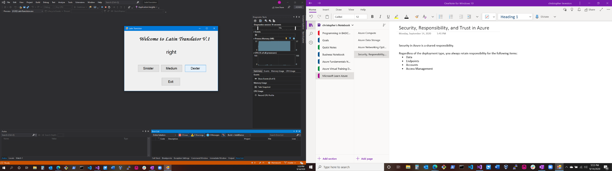Latin Translator Challenge

Math Tutor Chapter 2 Challenge

